Project Design Phase-II
Data Flow Diagram & User Stories

Date | 05 October 2026
Team ID | SWTID-2026-4248
Project Name | LearnMate AI StudyBuddy
Maximum Marks | 4 Marks

Data Flow Diagrams:
A Data Flow Diagram (DFD) is a traditional visual representation of the information flows within a system. A neat and clear DFD can depict the right amount of the system requirement graphically. It shows how data enters and leaves the system, what changes the information, and where data is stored.
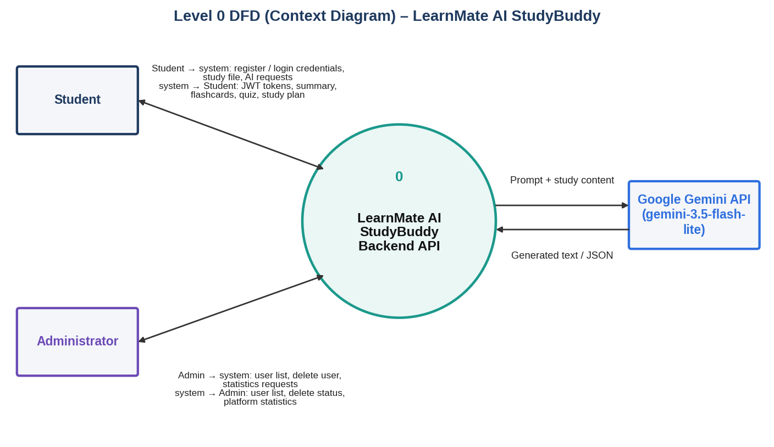
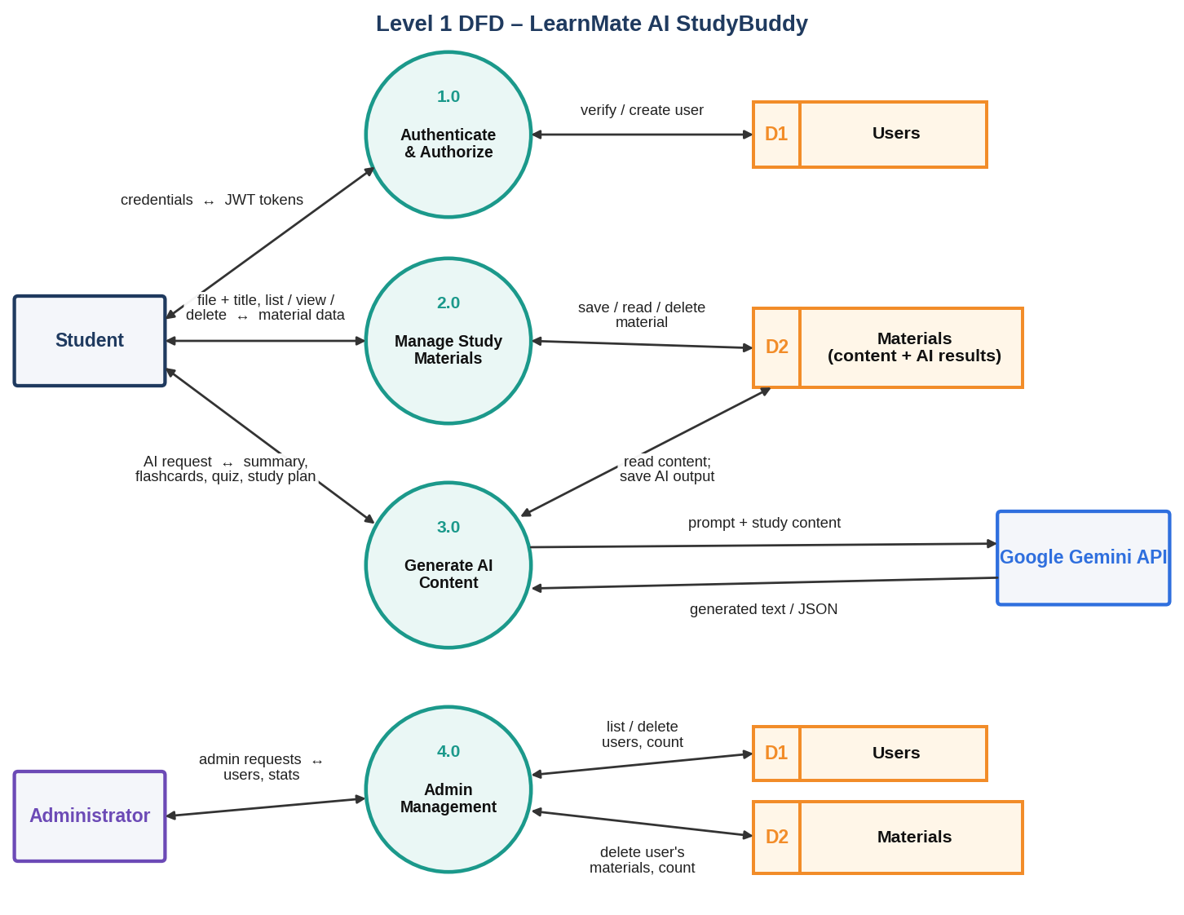

User Stories
Use the below template to list all the user stories for the product.
User Type | Functional Requirement (Epic) | User Story Number | User Story / Task | Acceptance criteria | Priority | Release
Student | Registration | USN-1 | As a student, I can register by entering my name, email and password so that my account is created securely. | Account is created and stored in MongoDB with a bcrypt-hashed password (HTTP 201); duplicate email is rejected | High | Sprint-1
Student |  | USN-2 | As a user, I receive an access token and a refresh token when I register so that I am signed in immediately. | Response contains accessToken, refreshToken and user details | High | Sprint-1
Student | Login | USN-3 | As a registered user, I can log in with my email and password so that I can use the AI features. | Valid credentials return JWT tokens (HTTP 200); invalid credentials return 401 | High | Sprint-1
Student |  | USN-4 | As a user, I can refresh my session with my refresh token and log out so that my account stays secure. | POST /refresh returns new tokens; logout returns a confirmation message | Medium | Sprint-1
Student | Authorization (RBAC) | USN-5 | As a user, I can access private APIs only with a valid Bearer token so that my data is protected. | Requests without a valid token receive 401 Not authenticated / Invalid or expired token | High | Sprint-1
Administrator |  | USN-6 | As an administrator, I have role-based access so that admin-only routes are restricted to admins. | Student token on /api/admin routes returns 403 Admins only | High | Sprint-1
Student | Security | USN-7 | As a user, I want my password stored in encrypted form so that my credentials cannot be misused. | Password saved as a bcrypt hash (10 salt rounds), never in plain text | High | Sprint-1
Student | Study Material Management | USN-8 | As a student, I can upload a .txt, .md or .pdf study file with an optional title so that it can be used for AI generation. | File up to 5 MB is saved as a material (HTTP 201); other file types are rejected | High | Sprint-2
Student |  | USN-9 | As a student, I can list all my uploaded materials so that I can pick one to study. | Only my own materials are returned, newest first | High | Sprint-2
Student |  | USN-10 | As a student, I can open one material to see its content and saved AI results. | Own material is returned; another user's material returns 403 | Medium | Sprint-2
Student |  | USN-11 | As a student, I can delete a material I no longer need. | Material is removed and a Deleted message is returned | Medium | Sprint-2
Developer | Database | USN-12 | As a developer, I can connect the API to MongoDB and define User and Material schemas so that data is stored reliably. | Server starts only after MongoDB connects; schemas validate input | High | Sprint-2
Student |  | USN-13 | As a student, I get a clear error for invalid uploads and the temporary file is cleaned up. | Wrong type or oversize file returns an error message; uploaded temp file is deleted | Medium | Sprint-2
Student | AI Summary | USN-14 | As a student, I can generate a concise bullet-point summary of a material so that I can revise quickly. | Gemini summary is returned (HTTP 200) and saved in the material | High | Sprint-3
Student | AI Flashcards | USN-15 | As a student, I can generate a chosen number of flashcards from a material for active recall. | JSON list of question/answer cards is returned and saved | High | Sprint-3
Student | AI Quiz | USN-16 | As a student, I can generate a multiple-choice quiz to test my understanding. | Questions with four options and an answer are returned and saved | High | Sprint-3
Student | AI Study Plan | USN-17 | As a student, I can generate a day-wise study plan from my goal, hours per day and number of days. | Personalised plan text is returned and saved in the material | High | Sprint-3
Administrator | Admin Management | USN-18 | As an administrator, I can view all registered users (without passwords) to monitor the platform. | Users are listed newest first with password excluded | Medium | Sprint-4
Administrator |  | USN-19 | As an administrator, I can delete a user together with all their materials. | User and materials are removed; unknown id returns 404 | Medium | Sprint-4
Administrator |  | USN-20 | As an administrator, I can view platform statistics (total students and materials). | totalUsers and totalMaterials counts are returned | Low | Sprint-4
Tester | Testing & Documentation | USN-21 | As a tester, I can verify every API in Postman so that the system is validated before release. | All seven core API calls return the expected status codes with evidence screenshots | High | Sprint-4
Developer |  | USN-22 | As a team, we prepare the complete project documentation and phase-wise templates. | Documentation covers architecture, setup, code, execution and testing | Medium | Sprint-4

